Chapter 4
Continuous time Fourier Transform

This chapter introduces the Fourier Transform, also known as the Fourier Integral. The definition, theorems, and properties are presented and proved. The Fourier transforms of the most common functions are derived, the system function is defined, and several examples are given to illustrate its application in circuit analysis.

Definition and Special Forms

We recall that the Fourier series for periodic functions of time, such as those we discussed on the previous chapter, produce discrete line spectra with non-zero values only at specific frequencies referred to as harmonics. However, other functions of interest such as the unit step, the unit impulse, the unit ramp, and a single rectangular pulse are not periodic functions. The frequency spectra for these functions are continuous as we will see later in this chapter.
We may think of a non-periodic signal as one arising from a periodic signal in which the period extents from 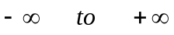 . Then, for a signal that is a function of time with period from , we form the integral

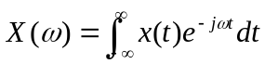
and assuming that it exists for every value of the radian frequency , we call the function 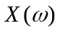the Fourier transform or the Fourier integral.

The Fourier transform is, in general, a complex function. We can express it as the sum of its real and imaginary components, or in exponential form, that is, as

The Inverse Fourier transform is defined as

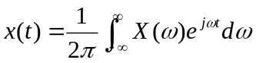

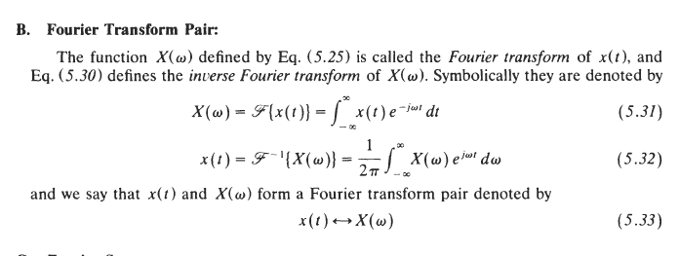
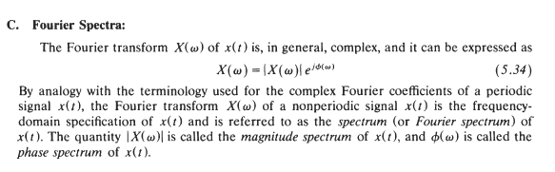

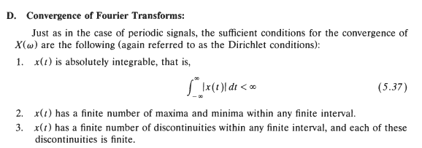
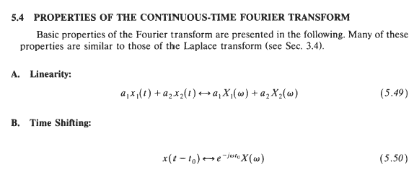
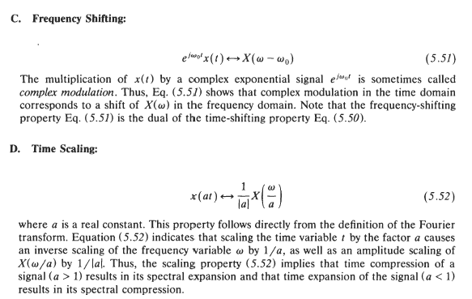
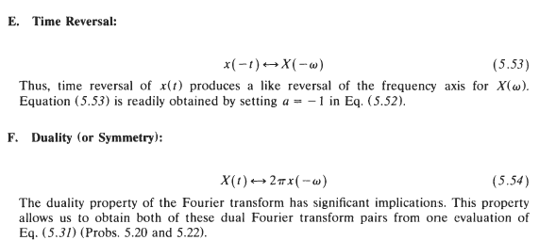
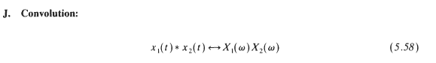
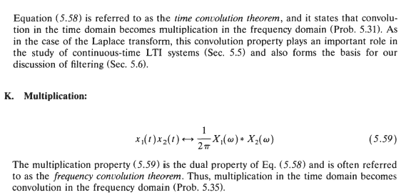

The Discrete Fourier Transform

The DFT is a mathematical procedure used to determine the harmonic, or frequency, content of a discrete signal sequence.
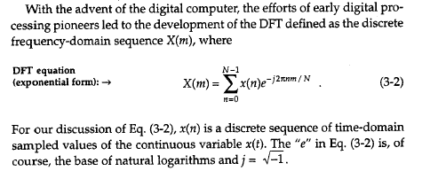
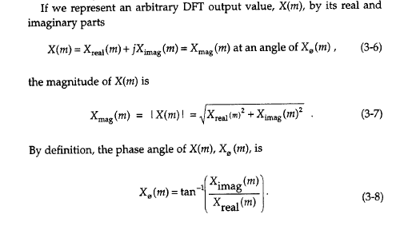
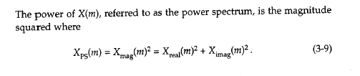
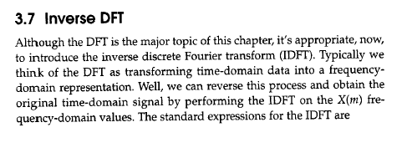
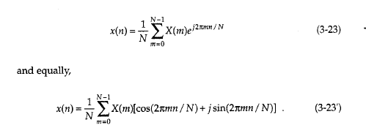
Features of DFT
